Grade 7 Accelerated · Unit 4 · Lesson 6  Order of Operations with Radicals  Independent Set 4.06 ANSWER KEY | Name  Date  Period

Six questions, on your own, in silence. Show the step that does the work.
1. 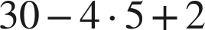
12

2. 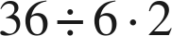
12
One level, left to right.

3. 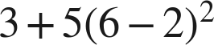
83
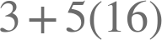.

4. 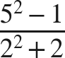
4
24 over 6.

5. 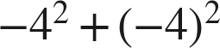
0

6. 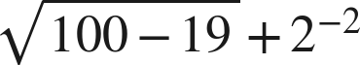

Under the bar: 81, whose root is 9. Then 

